**Laboratory 1**

שם הסטודנט:

ת.ז.: ______

נא לשלוח למודל

In this laboratory work we are learning how to create a simple network, and set up IP address to end point station (computer, printer and etc.). In **Part 1** we use the network simulation program “Cisco Packet Tracer” to learn how to create a simple network. In **Part 2** we examine network environment where yours computer work. In **Part 3** we create point-to-point network.

**Part 1. Learn how to Use Packet Tracer.**

Open a program of network simulation “Packet Tracer”.

**Create/model a simple Ethernet network.**

* Select devices for network.

The bottom left-hand corner of the Packet Tracer screen displays eight icons that represent device categories or groups, such as Routers, Switches, or End Devices.

Moving the cursor over the device categories will show the name of the category in the box. To select a device, first select the device category. Once the device category is selected, the options within that category appear in the box next to the category listings. Select the device option that is required.

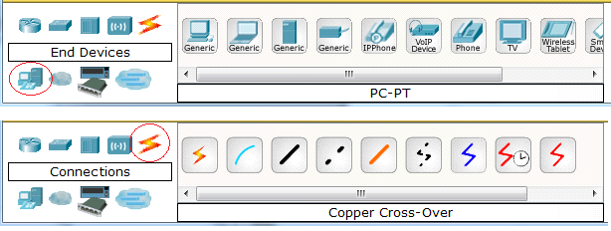

* Select **End Devices** from the options in the bottom left-hand corner. Drag and drop four Generic PCs and two Generic Servers onto the design area.
* Select **Switches** from the options in the bottom left-hand corner. Drag and drop three Generic Switches onto the design area.
* Select **Connections** from the bottom left-hand corner. Choose a **Copper Straight-Through** cable type. Click the first host, **PC0**, and assign the cable to the **FastEthernet** connector. Click the switch, **Switch0**, and select a connection port, **FastEthernet0/1 (Fa0/1)**, to connect to **PC0**. Connect **PC1** to interface **Fa1/1** on **Switch0**. Using straight-through cables connect **PC2**, **PC3** to interfaces **Fa0/1** and **Fa1/1** on **Switch1**. Connect **Server0** and **Server1** to **Switch2**.

Choose a **Copper Cross-Over** cable type. Connect port **Fa2/1** on **Switch1** to port **Fa2/1** on **Switch2**.

Choose a **Fiber** cable type. Connect port **Fa4/1** on **Switch0** to port **Fa4/1** on **Switch2**.

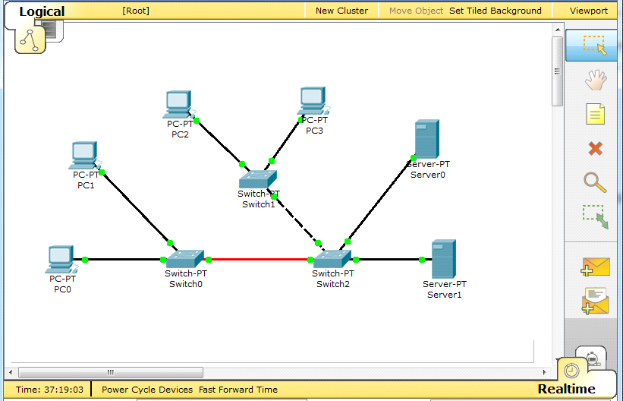

* Set IP address for hosts.
* Click **PC0**. A PC0 window will appear. From the PC0 window, select the **Config** tab. Select **FastEthernet** on the left tab and add the IP address of **192.168.1.10** and subnet mask of **255.255.255.0**. Close the PC0 configuration window by selecting the **x** in the upper right-hand corner.
* Set IP address for hosts

**PC1** address **192.168.1.11** mask **255.255.255.0**.

**PC2** address **192.168.1.12** mask **255.255.255.0**.

**PC3** address **192.168.1.13** mask **255.255.255.0**.

**Server0** address **192.168.1.14** mask **255.255.255.0**.

**Server1** address **192.168.1.15** mask **255.255.255.0**.

* Check connections between hosts, if connection is fault fix it.
* Click **PC0**. From the PC0 window, select the **Desktop** tab. Choose the **Command Prompt**. Type **ping 192.168.1.13** and press *enter*.

A successful **ping** indicates the network was configured correctly and the prototype validates the hardware and software configurations. A successful ping should resemble the below output:

**PC>ping 192.168.1.13**

**Pinging 192.168.1.13 with 32 bytes of data:**

**Reply from 192.168.1.13: bytes=32 time=170ms TTL=128**

**Reply from 192.168.1.13: bytes=32 time=71ms TTL=128**

**Reply from 192.168.1.13: bytes=32 time=70ms TTL=128**

**Reply from 192.168.1.13: bytes=32 time=68ms TTL=128**

**Ping statistics for 192.168.1.13:**

**Packets: Sent = 4, Received = 4, Lost = 0 (0% loss),**

**Approximate round trip times in milli-seconds:**

**Minimum = 68ms, Maximum = 170ms, Average = 94ms**

Close the configuration window.

* Check connections between hosts.

Make ping from **PC1** to **Server0**.

Make ping from **PC3** to **Server1**.

Make ping from **PC2** to **PC0**.

Save this simulation file with name ***Lab1-ת.ז***.

**Part 2. Exanimate IP addresses settings of your computer.**

* Determine IP setting from Command Prompt window.

Exit to *Command Prompt* (write ***cmd*** in Run window).

* Run the command ***ipconfig /all*** .

Fill the followed table for interface “Local Area Connection”:

|  |  |
| --- | --- |
| Network Interface Name | Local Area Connection |
| Computer Name (host name) | DESKTOP-VB4GCAT |
| IP Address | 192.168.50.63 |
| Subnet mask | 255.255.255.0 |
| Default Gateway | 192.168.50.1 |
| DNS server | 8.8.8.8 |
| DHCP Enabled | Yes |
| DHCP Server IP address | 192.168.50.1 |
| MAC Address (physical address) | 64-00-6A-55-40-7D |

Put Screen capture window with IP address details (use alt + PrtScn)

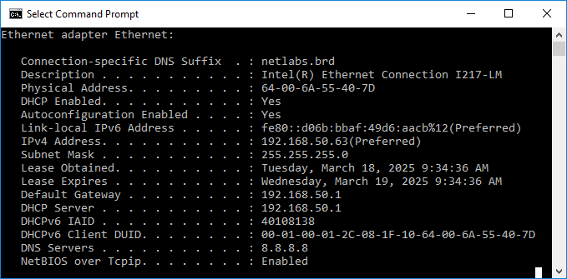

**Part 3. Create an Ethernet network.**

**לפני תחילת העבודה, על מנת לאפשר למחשבים אחרים לשלוח הודעות למחשב שלכם, תצטרכו לנטרל את חומת האש (FIRE WALL) שמגנה על המחשב שלכם.**

**במעבדה ננטרל את חומת האש לרשת הפנימית.**

**לחצו על start והקלידו windows firewall והיכנסו לתוצאה שמתקבלת.**

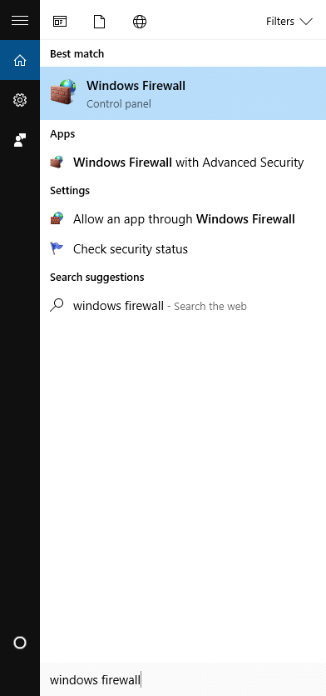

**בחלון ההגדרות, לחצו בצד שמאל על Turn windows firewall on or off**

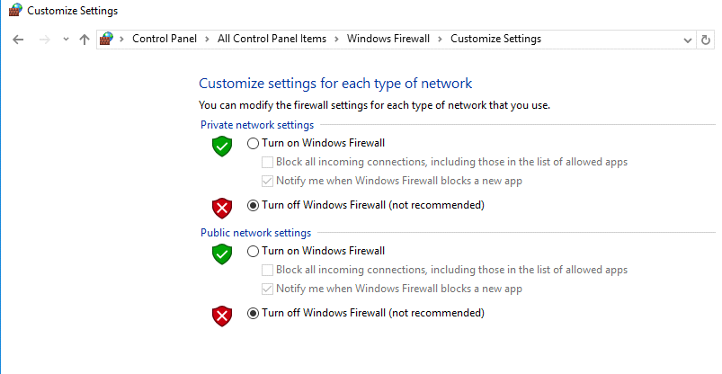

**כעת, הגדירו בקטגוריה Private network settings את האפשרות Turn off Windows Firewall ולחצו OK.**

In this part of laboratory work, we will have to build and configure the simple network. We will connect two computers to the switch, assign to computers relevant IP address, and then check connections between computers.

To reduce the number of physical switches, we use the technology of virtual networks (VLAN). In compliance with this technology, we can assign ports on same switch to different networks. Switches are used for laboratory work is divided into two virtual switch. Ports 1 through 12 first virtual switch, ports 13 - 24 second virtual switch.

By default, all computers connects to the one main switch, which called “Sw-Main”. In laboratory work you need disconnect your computer from main switch, and connect it to another switch, depend on the network to which the computer belong, as in the following picture below.

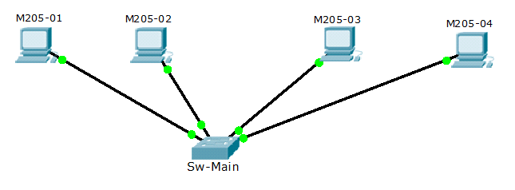

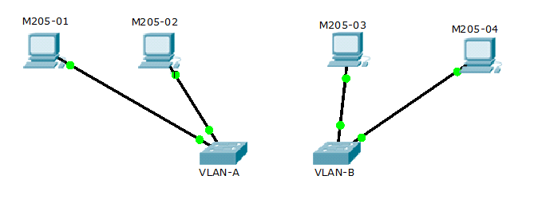

* Connecting the computer to switch.
* In your workplace to determine the number of socket at which your computer is connected to raceway. Your computer connects to socket by black cable.

In laboratory communication closet, determine is which cable your computer connects to the switch "Sw-Main". This is a cable which connected, from patch panel socket with same number as on your workplace socket number, to the switch “Sw-Main”. Use this cable and reconnect your computer to another switch. Use the switch in compliance with the network to which your computer is applied.

For example, if a computer belong to VLAN-31, this is computer must be connected to any available port on the switch where VLAN-31 is defined and port assign to VLAN-31.

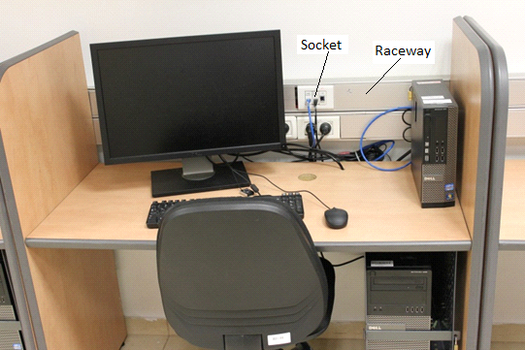

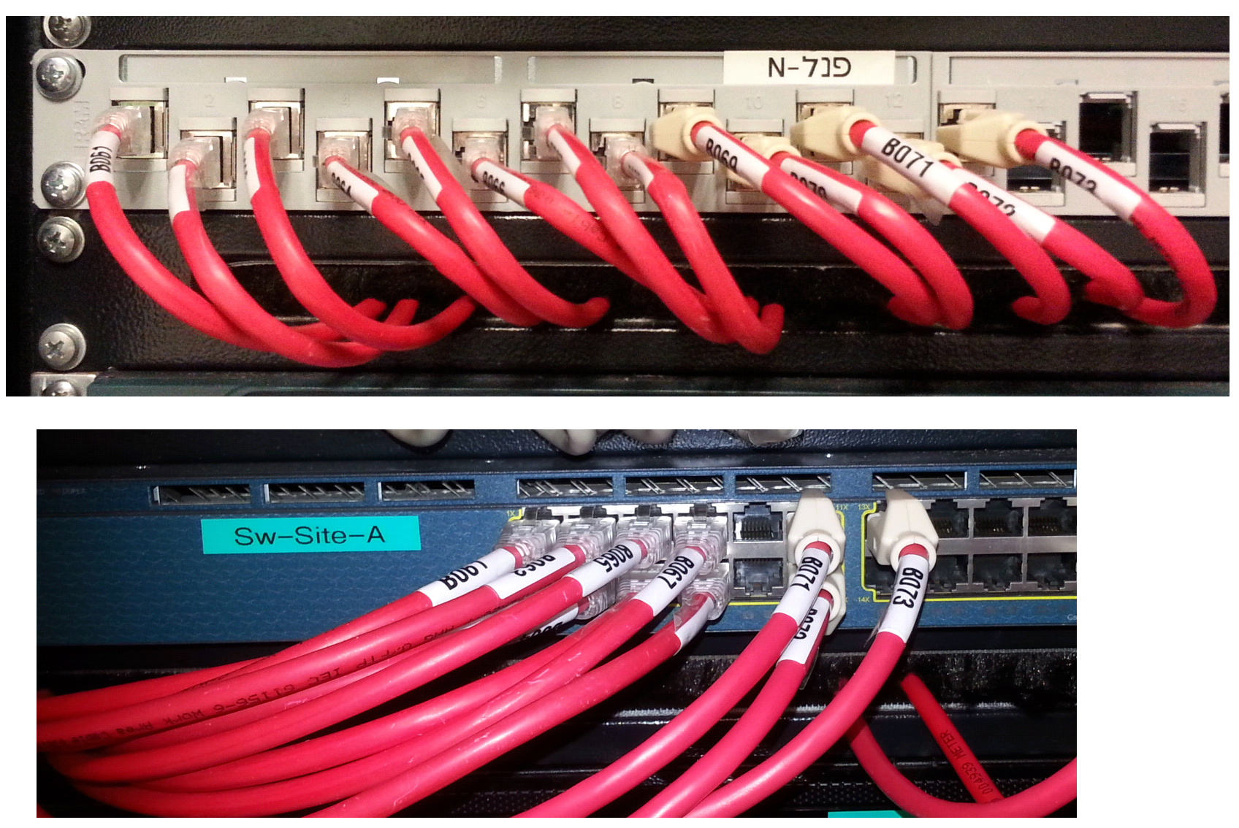

* You need to assign IP address to your computer **manually**. You have to use network shell (***netsh***) commands.

You have to use IP address from range **192.168.X.[2_253]** with network mask **255.255.255.0** and default gateway **192.168.X.1**. Where X is in range 31 – 35 and this is a VLAN number.

* Define the IP address is setting to network card (NIC) on your computer.

Interface Name: _____Ethernet________

VLAN id number. ____32_____

IP address: _____192.168.32.10__________

Network mask: _____255.255.255.0_______

Default gateway: ___192.168.32.1_______

* On your computer launch “Command Prompt”, use command cmd.exe. In command prompt run program **netsh**.
* Determine the status of network interface that your computer is connected to another computer. Work in **Interface context** of network shell (***netsh***). Type command ***interface*** enter to the Interface context. Use command ***show interface*** to determine status of network interface on computer.

Write the Interface Name __Ethernet__

State of interface (enabled or disabled) __Enabled____

Status of interface (connected or disconnected) __Connected____

* To set IP address for NIC using network shell (netsh) you, from Interface context, enter to ipv4 subcontext by typing command ***ipv4***. You need use two command. First command you set IP address with network mask and default gateway, and second command to set IP address of DNS server. Use command **"?**" to help for right syntax of command. For example: ***"netsh interface ipv4>set ?"***

**Set IP address example:**

*set address name=“<Interface name>” source=static address=<IPv4 address> mask=<network mask> gateway=<IPv4 address>*

Write the Command:_set address name="Ethernet" source=static address=192.168.32.10 mask=255.255.255.0 gateway=192.168.32.1__

* Check connection between comp uters. Use command ***ping*** to determine that connection between computers is established.

Put Screen capture window with ping command result (use alt + PrtScn)

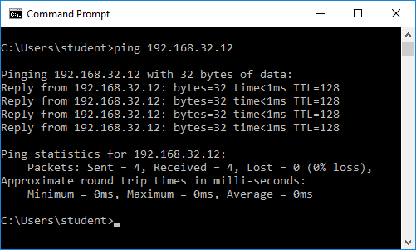

* In laboratory communication closet connect cable of your computer back to switch "Sw-Main".
* On your computer from the Control Panel -> Network and Sharing Center-> Change adepter settings.
* Right click the local area connection: Ethernet ->properties
* In the “ this connection uses the following items” box, click internet protocol version 4 (TCP/IPv4) then click properties

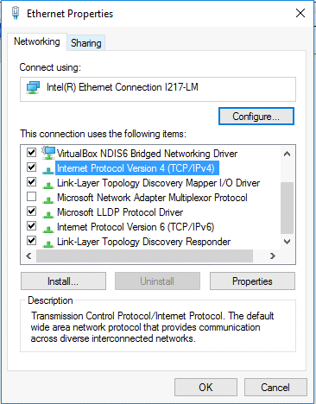

Set IP address to Local Area Connection automatically

* Chose “obtain an IP address automatically” and “obtain DNS server address automatically”

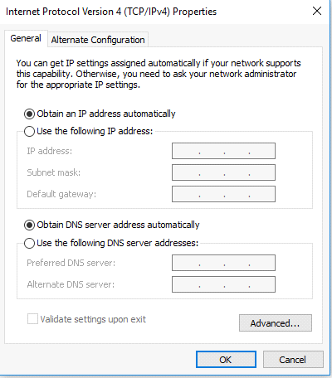

Send to lecturer two files (this Word document and file of network simulation).

**Thank you**